Experiment / Case Study 2

Experiment Title: Use var, let, const, and demonstrate basic features like template literals and destructuring; build a billing calculator with user input.
Software / Tools Required: VS Code, JavaScript, HTML/CSS, Web browser
Experiment Program Code:
BillingCalculator.html (HTML/CSS File)
<!DOCTYPE HTML>
<html>
<head>
<meta charset="UTF-8">
<title>Billing Calculator</title>
<style>

h2 {
text-align: center;
font-family: 'Trebuchet MS', 'Lucida Sans Unicode', 'Lucida Grande', 'Lucida Sans', Arial, sans-serif;
}

h3 {
text-align: center;
font-family: 'Trebuchet MS', 'Lucida Sans Unicode', 'Lucida Grande', 'Lucida Sans', Arial, sans-serif;
}

.form {
margin-left: 20%;
margin-right: 20%;
margin-top: 50px;
background-color: rgb(77, 173, 218);
border-radius: 20px;
padding: 10px;
}

label {
font-family: 'Lucida Sans', 'Lucida Sans Regular', 'Lucida Grande', 'Lucida Sans Unicode', Geneva, Verdana, sans-serif;
font-size: 16px;
margin-left: 15px;
}

input {
border-radius: 5px;
box-shadow: rgb(0, 0, 0);
}

.btn {
text-align: center;
}

button {
background-color: crimson;
font-family: 'Gill Sans', 'Gill Sans MT', Calibri, 'Trebuchet MS', sans-serif;
margin-top: 10px;
}

</style>
</head>
<body style="background-color: wheat;">
<h2 style="color: rgb(0, 0, 0); font-family: 'Gill Sans', 'Gill Sans MT', Calibri, 'Trebuchet MS', sans-serif;">Grocery Store</h2>
<div class="form">
<label>Customer Name: </label>
<input type="text" id="name" placeholder="John Doe">
<br><br>
<label>Product Name: </label>
<input type="text" id="product" placeholder="Apple">
<br><br>
<label>Price: </label>
<input type="number" id="price" placeholder="10">
<br><br>
<label>Quantity: </label>
<input type="number" id="quantity" placeholder="1">
<br>
</div>
<div class="btn">
<button onclick="calculateBill();">Generate Bill</button><br><br>
</div>
<hr>
<div id="output"></div>
<br><br>
<h3>Designed by Arunima Das, PRN: 24070521007</h3>
<script src="C:\Users\sit.lab7\BillScript.js"></script>
</body>
</html>
BillScript.js (JavaScript File)
function calculateBill() {
var customerName = document.getElementById("name").value;

let product = document.getElementById("product").value;
let price = Number(document.getElementById("price").value);
let quantity = Number(document.getElementById("quantity").value);

const GST = 0.18;

let subtotal = price*quantity;
let gstAmount = subtotal*GST;
let total = subtotal + gstAmount;

const bill = {
customerName,
product,
subtotal,
gstAmount,
total
};

const {customerName : name, product : product1, subtotal : st, gstAmount : gst, total : total1} = bill;

//Template Literal

document.getElementById("output").innerHTML =
`
<h3>Customer Name: ${name}</h3>
<br>
<h3>Product Name: ${product1}</h3>
<br>
<h3>Subtotal: ${st}</h3>
<br>
<h3>GST Amount: ${gst}</h3>
<br>
<h2>Total Amount: ${total1}</h2>
`

console.log(`Customer Name: ${name}`);
console.log(`Product Name: ${product1}`);
console.log(`Subtotal: ${st}`);
console.log(`GST Amount: ${gst}`);
console.log(`Total Amount: ${total1}`);
}

Output:
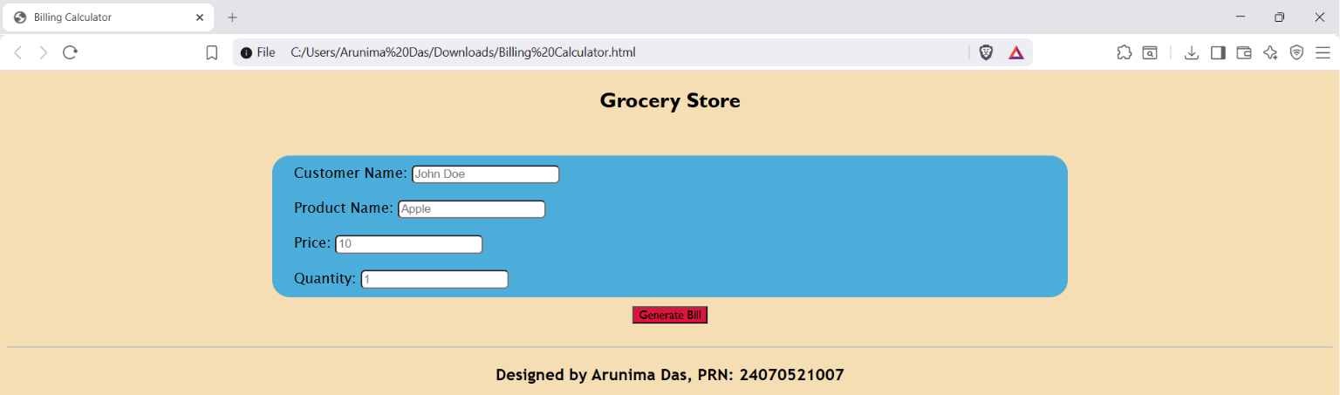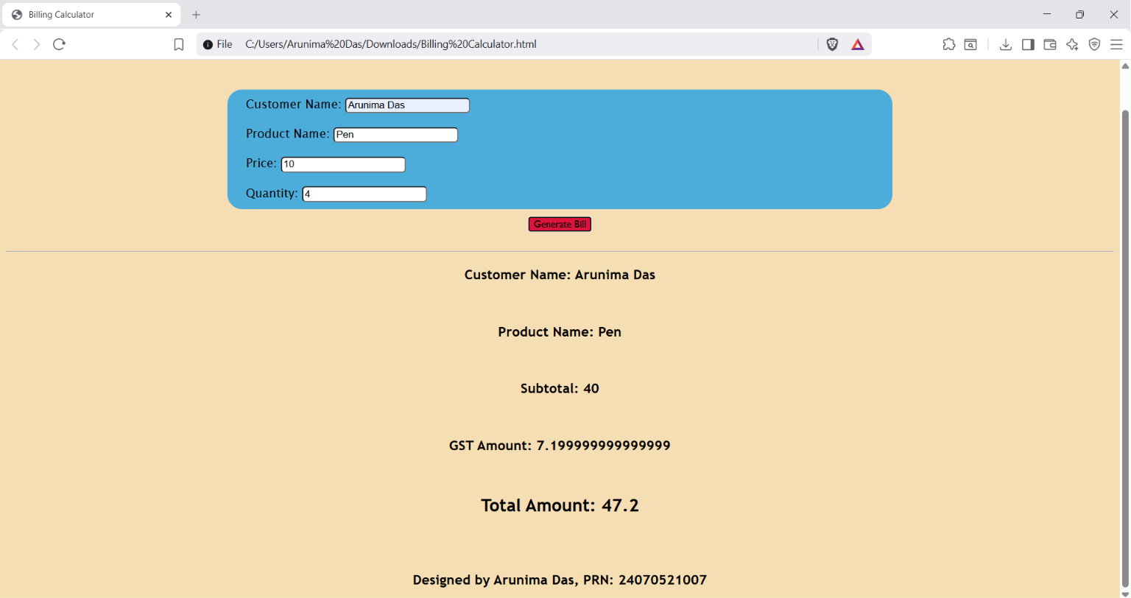

Case Study Title: Create a webpage for a shopping website. Implement the billing calculator in it, and show the final price.
Case Study Program Code:
OnlineShopping.html (HTML/CSS File)
<!DOCTYPE HTML>
<html>
<head>
<meta charset="UTF-8">
<title>Online Shopping Website</title>
<style>
h2 {
text-align: center;
font-family: Verdana, Geneva, Tahoma, sans-serif;
color:rgb(81, 146, 15);
}

h3 {
text-align: center;
font-family: Verdana, Geneva, Tahoma, sans-serif;
color:rgb(81, 146, 15);
}

.menu {
display: grid;
grid-template-columns: auto auto auto auto;
grid-template-rows: auto auto;
margin-top: 15%;
margin-left: 10%;
margin-right: 10%
}

.menu div {
background-color: whitesmoke;
color: black;
border: 1px solid black;
margin-right: 10px;
font-family:'Segoe UI', Tahoma, Geneva, Verdana, sans-serif;
border-radius: 15px;
box-shadow: 0 10px 20px rgba(0, 0, 0, 0.1);
padding: 10px;
}

.form {
background-color: rgb(81, 146, 15);
margin-top: 30px;
padding: 10px;
margin-left: 20%;
margin-right: 20%;
}

.form label {
font-family: 'Segoe UI', Tahoma, Geneva, Verdana, sans-serif;
font-size: 16px;
margin-left: 10px;
}

.form input {
font-size: 16px;
margin-left: 5px;
border: 1px solid black;
box-shadow: 0 5px 10px rgba(0, 0, 0, 0.1);;
}

.btn {
text-align: center;
}

button {
background-color: rgb(50, 128, 230);
font-family: 'Gill Sans', 'Gill Sans MT', Calibri, 'Trebuchet MS', sans-serif;
font-size: 20px;
}
</style>
</head>
<body style="background-color: rgb(230, 195, 41);">
<h2>Welcome to Blicki!</h2>
<div class="menu">
<div>
<img src="washing-machine-1994661_640.jpg" alt="Washing Machine" width="150" height="150">
<p>Washing Machine</p>
<p>Price: ₹18,000</p>
</div>
<div>
<img src="washing-machine-1994661_640.jpg" alt="Washing Machine" width="150" height="150">
<p>Washing Machine</p>
<p>Price: ₹18,000</p>
</div>
<div>
<img src="washing-machine-1994661_640.jpg" alt="Washing Machine" width="150" height="150">
<p>Washing Machine</p>
<p>Price: ₹18,000</p>
</div>
<div>
<img src="washing-machine-1994661_640.jpg" alt="Washing Machine" width="150" height="150">
<p>Washing Machine</p>
<p>Price: ₹18,000</p>
</div>
</div>
<h3>Enter the products you want to buy</h3>
<div class="form">
<label>Customer Name: </label>
<input type="text" id="customer" placeholder="John Doe">
<br><br>
<label>Product Name: </label>
<input type="text" id="product" placeholder="Apple">
<br><br>
<label>Price: </label>
<input type="number" id="price" placeholder="10">
<br><br>
<label>Quantity: </label>
<input type="number" id="quantity" placeholder="1">
<br><br>
<label>Discount (in %): </label>
<input type="number" id="discount" placeholder="2">
</div>
<br><br>
<div class="btn">
<button onclick="calculateBill();">Generate Bill</button>
</div>
<br>
<hr>
<br>
<div id="output"></div>
<h3>Designed by Arunima Das, PRN: 24070521007</h3>
<script src="ShoppingScript.js"></script>
</body>
</body>
</html>
ShoppingScript.js (JavaScript File)
function calculateBill() {
var customerName = document.getElementById("customer").value;

let product = document.getElementById("product").value;
let price = Number(document.getElementById("price").value);
let quantity = Number(document.getElementById("quantity").value);
let discount = Number(document.getElementById("discount").value);

const GST = 0.18;

let subtotal = price*quantity;
let gstAmount = subtotal*GST;
let gstTotal = subtotal + gstAmount;
let discountAmount = (gstTotal/100)*discount;
let total = gstTotal - discountAmount;

const bill = {
customerName,
product,
subtotal,
gstAmount,
gstTotal,
discountAmount,
total
};

const {customerName : name, product : prod, subtotal : st, gstAmount : gst, gstTotal : gt, discountAmount : dis, total : at} = bill;

document.getElementById("output").innerHTML =
`
<h3>Customer Name: ${name}</h3>
<br>
<h3>Product Name: ${prod}</h3>
<br>
<h3>Subtotal: ₹${st}</h3>
<br>
<h3>GST Amount: ₹${gst}</h3>
<br>
<h3>Total with GST: ₹${gt}</h3>
<br>
<h3>Discounted Amount: ₹${dis}</h3>
<br>
<h2>Total: ₹${at}</h2>
<br>
`

console.log(`Customer Name: ${name}`);
}

Output:
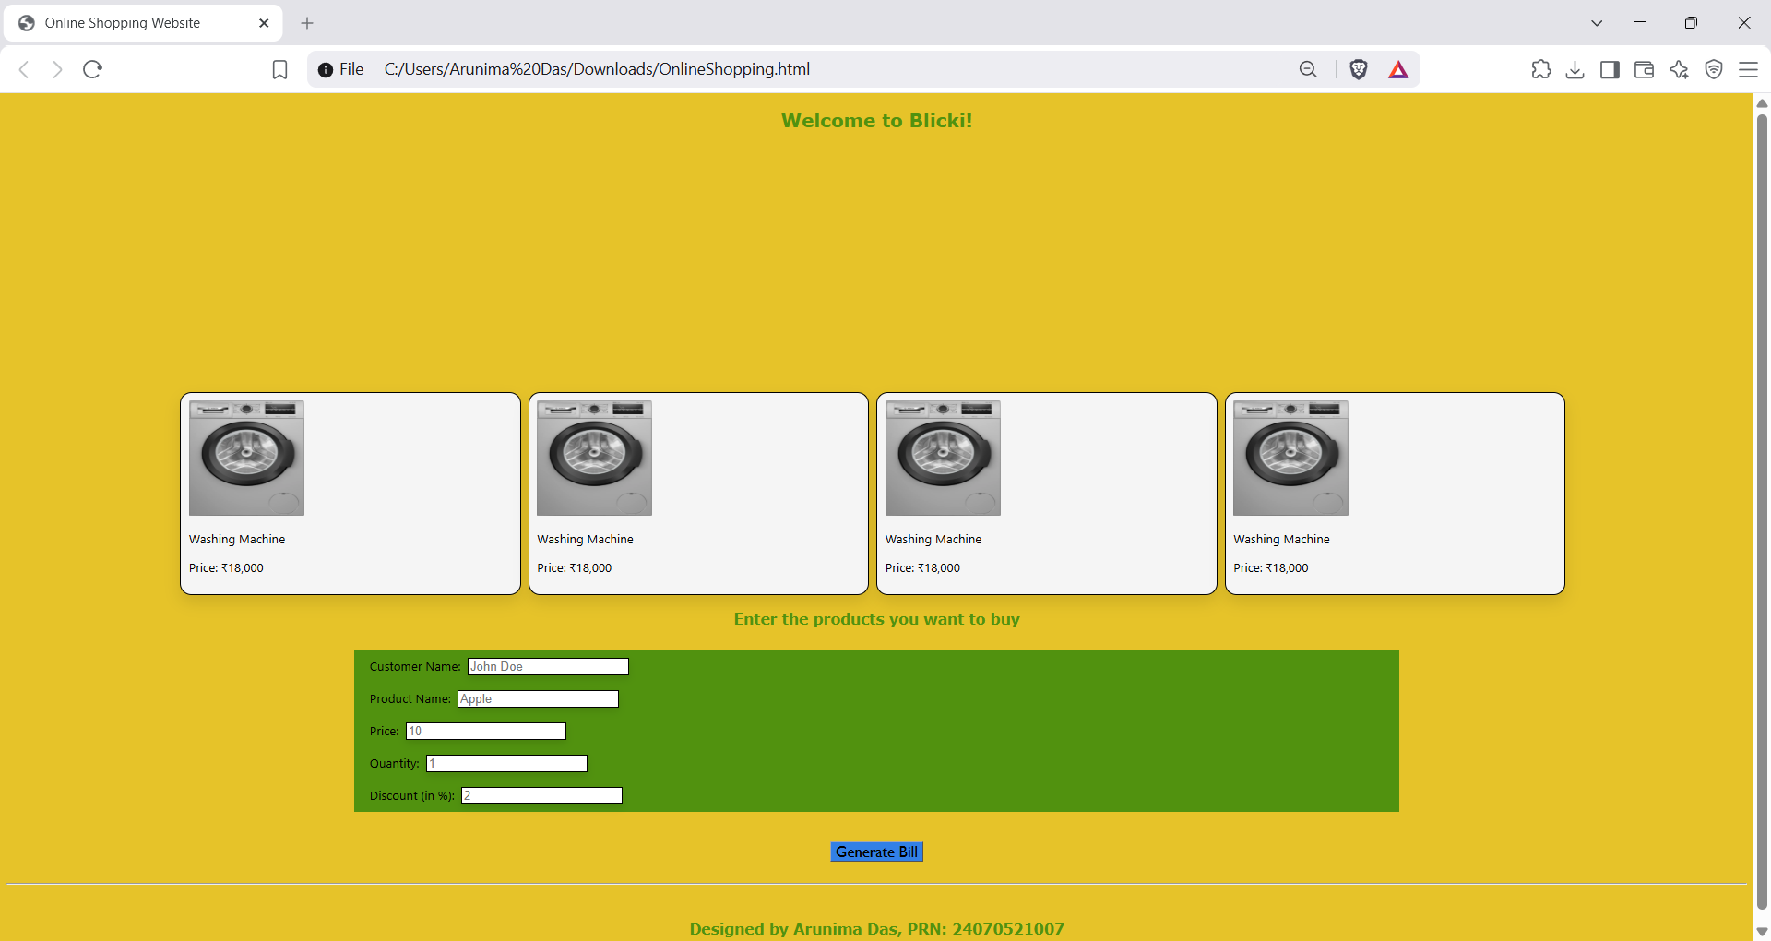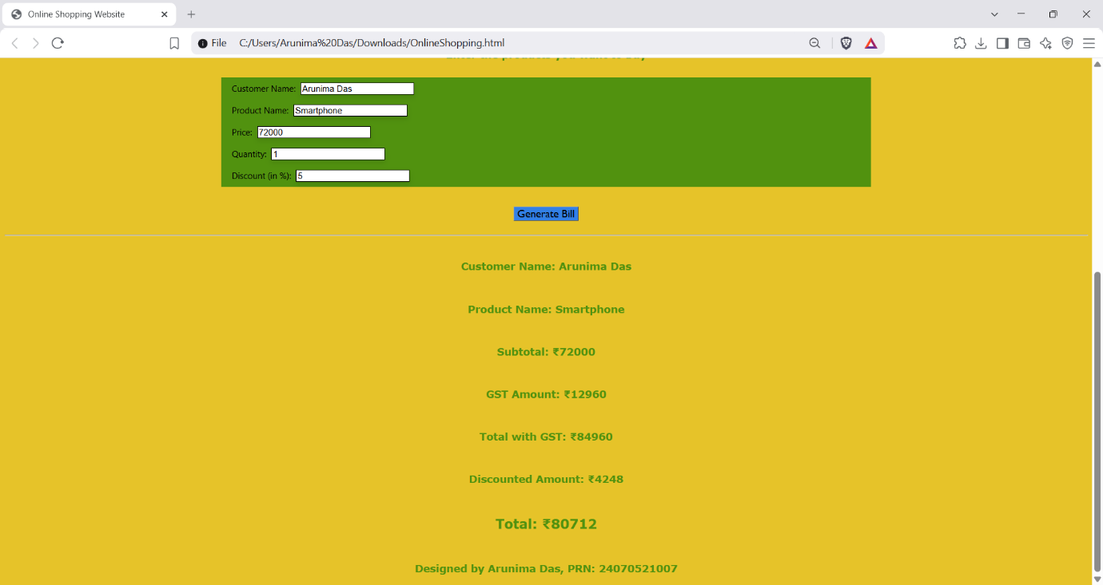

Conclusion: Thus, by defining the variables needed for a bill for the grocery store, we calculated the needed values: subtotal, GST total, discounted amount, and the grand total.
The template literals were used to display the values easily, and the object ‘bill’ was destructured. Hence, the user can see the total cost of their order

